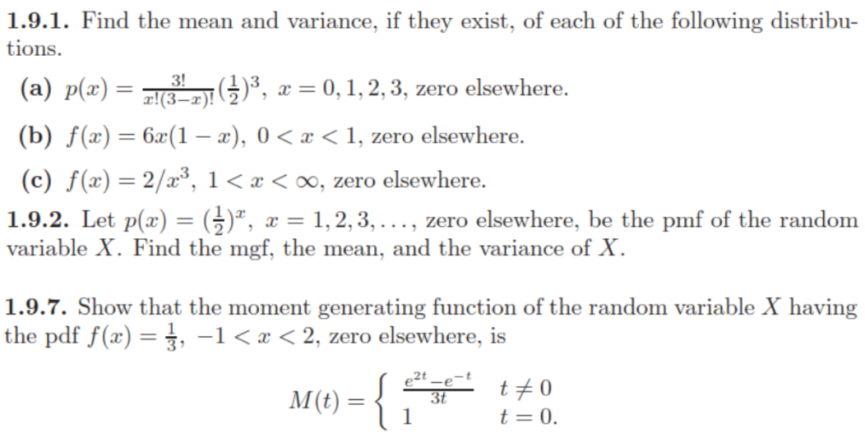

1. **Expected value**

* Diskrit

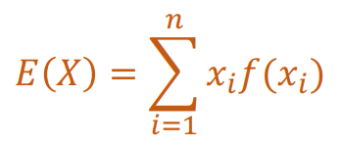

* Kontinyu

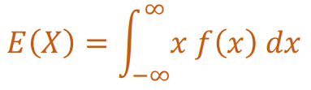

1. **Variance**

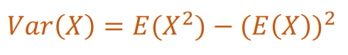

1. **MGF (Moment Generating Function)**

* Diskrit

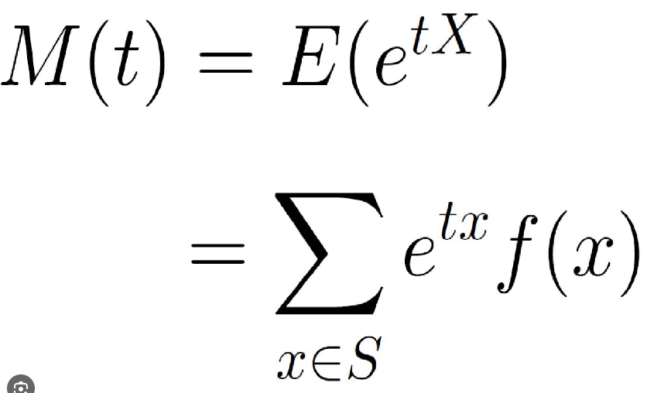

* Kontinu

